- How do I apply?
Complete the online musical aptitude application form available via our website under Admissions or call the Academy on 01952 386049 to have an application posted to you. www.haberdashersabrahamdarby.co.uk
- When do I need to apply by?
3.20pm on Tuesday 13 October 2026
- How are the pupils assessed?
Applicants will be invited to sit a musical aural test and a musical audition.
- When will the test be?
Saturday 17th October 2026
- Where will the test be?
At Haberdashers’ Abraham Darby – the Music Department
- What is in the Musical Aptitude Test?
The test will consist of 30 Questions and divided into three equal sections:-
Section 1: Pitch & Melody
Section 2: Instruments and Texture
Section 3: Rhythm, Metre and Tempo
- What is required for the Musical Audition?
The pupils perform either on their chosen instrument or vocally.
- Will there be a set musical piece?
No – it is a totally free choice of music.
- Who will judge the musical audition?
The music audition will be heard by the Head of Music or a Music Teacher.
- Where can I wait during the test and audition?
The parents of band members run a College Café in the school restaurant, and you will be able to wait there.
- When will I find out the results of the aptitude tests?
You will be contacted by
Friday 23rd October 2026
- When is your Open Evening?
Open Evening is on 1st October or appoints to visit at another time can be made by contacting 01952 386027 or via email mandie.rowson@taw.org.uk
- Who can I speak to about the Musical Aptitude Places
Miss Morton, Head of Music
01952 386000
rachel.morton@taw.org.uk
- Is there a band open day?
The Mega Band Open Morning is on Saturday 10th October 9.00 – 10.45am

The benefits of learning a
musical instrument

Music produces a kind of pleasure which human nature can not do without
Confucius

- Improves your organisational skills
- Improves Team Work
- Improves Co-ordination
- Improves your mathematical ability
- Improves your reading and comprehension skills
- Exposes you to culture
- Improves your concentration & listening skills
- Creates a sense of achievement
- Promotes your social skills
- Teaches you discipline
- Helps with your Self Confidence
- Gives you a Life Skill

What Musical Activities go on at the Academy?

After School Clubs
Monday CZ Band
Tuesday Choir
Wednesday Junior Jazz
Thursday Music Theory
Friday Friday Band

Senior Bands Tuesday night from 6 pm
6 – 6.45 pm Sax Ensemble
6 – 6.45 pm Percussion
7 – 8.30 pm Senior Jazz

Saturday Morning Music College 9 – 12
Band Times
8.45 – 10.45am Showband
9 – 10.45 am Mega Band
11 – 12 pm Senior Woodwind
11 – 12 pm Brass Band

Music Lesson for Year 3 - 6
Saturday Morning 9 am to midday

Some music lessons are available during the school day.

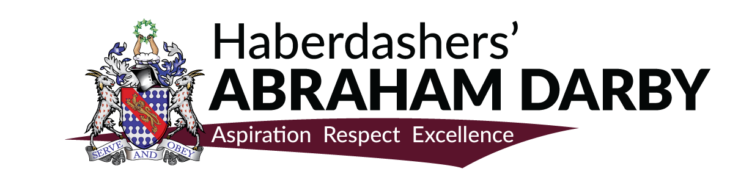
Band Successes

- Show Band invited to play at the Royal Albert Hall for Music for Youth School Proms
- Senior Jazz Band– Consistent Outstanding Achievement Award at NCBF
- Senior Jazz Band - Platinum award at the National Concert Band Festival
- Junior Jazz Band - Platinum award at the National Concert Band Festival
- Show Band - Platinum award at the National Concert Band Festival

- Showband invited to play at Llangollen International Eisteddfod Showband -
- Showband invited by Telford & Wrekin to play at their Festival of Remembrance

- Senior Jazz Band invited to play at the Royal Albert Hall for Music for Youth School Proms
- Showband – Consistent Outstanding Achievement Award at NCBF
- Senior Jazz Band - Platinum award at the National Concert Band Festival

Musical Aptitude Places

For September 2027

Haberdashers’ Abraham Darby can offer 12 places in Year 7 for September 2027 based on musical aptitude.

The Academy runs numerous award-winning bands that enable pupils to improve their skills and experience playing in such locations as the Symphony Hall in Birmingham and the Royal Albert Hall in London.

Haberdashers’ Abraham Darby offer FREE music lessons to all pupils.
Band Membership is an annual subscription of £20.00.

